# Objective

The primary objective of this project is to develop and evaluate a neural network model capable of accurately distinguishing between fake and real news articles. By leveraging natural language processing (NLP) techniques and deep learning architectures, the goal is to create a robust classiﬁer that can assist in mitigating the spread of misinformation.

# Problem Statement

The proliferation of fake news has signiﬁcant negative impacts on society, including the erosion of public trust and the skewing of democratic processes. Traditional methods of fact-checking are often labor-intensive and time-consuming. Therefore, there is a critical need for automated systems that can eﬃciently and effectively identify

potentially false information.

# Methodology

## Data Collection and Preprocessing

Two datasets were used in this project:

1. WELFake Dataset: Contains textual content labeled as real or fake.
2. Fake and Real News Dataset: Comprises separate ﬁles for fake and real news articles.

The preprocessing steps involved:

* Concatenation of Title and Text: For some datasets where separate ﬁelds for titles and text existed, these were concatenated to form a single text ﬁeld,

ensuring comprehensive feature extraction.

* Cleaning and Normalization:
  + Removing special characters and numbers.
  + Converting all text to lowercase to maintain consistency.
  + Removing stopwords to reduce noise and focus on meaningful words.
  + Lemmatization to reduce words to their base or dictionary form.

## Text Vectorization

We used the GloVe (Global Vectors for Word Representation) model for embedding words into numerical vectors. The GloVe model, pre-trained on a large corpus, maps words into a high-dimensional space where the distance and direction between vectors capture semantic relationships between words.

## Model Architecture

The model architecture is a hybrid neural network consisting of:

* Embedding Layer: Maps each word to a 300-dimensional vector, using the pre-trained GloVe embeddings.
* Spatial Dropout: Reduces overﬁtting by dropping entire 1D feature maps in the embedding space, enhancing model generalization.
* Convolutional Layer: Extracts higher-level features through ﬁlters that process parts of the input text.
* Bidirectional LSTM: Processes the text in both forward and reverse directions, capturing dependencies from both past and future contexts.
* Global Average Pooling: Reduces the dimensionality of the feature map while retaining important information.
* Dense Layers and Batch Normalization: A fully connected layer with batch normalization follows, introducing non-linearity and scaling the inputs to stabilize and speed up training.
* Output Layer: Comprises two units with a sigmoid activation function, providing the probabilities for the two classes (fake and real).

Model 1:

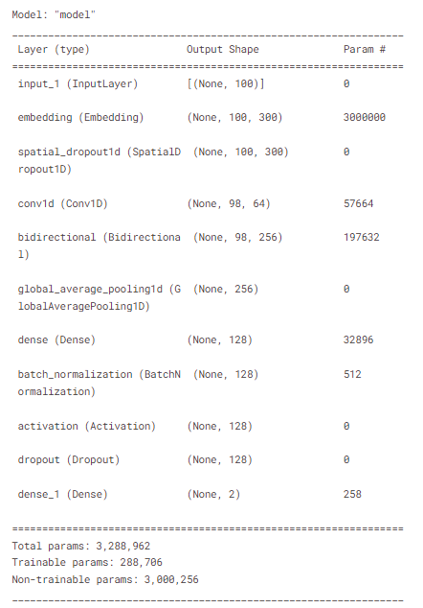 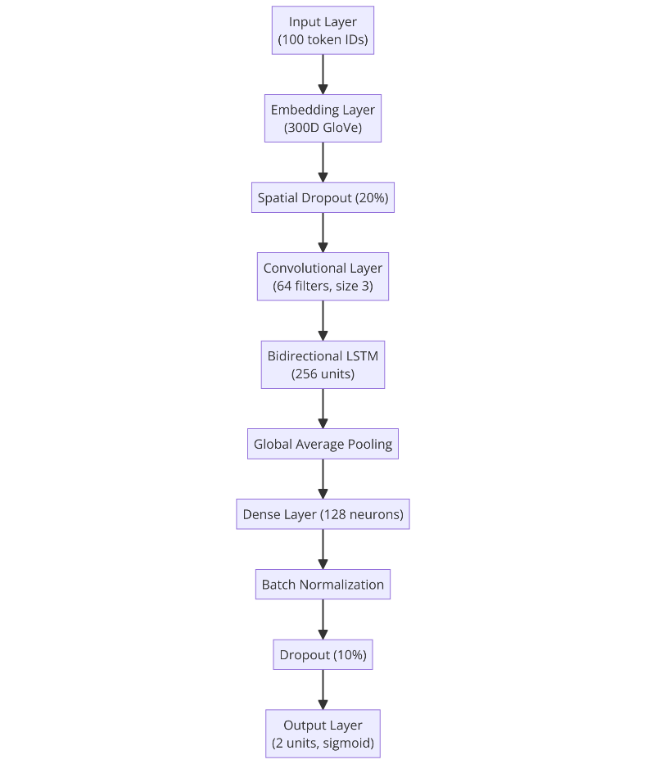

Model 2:

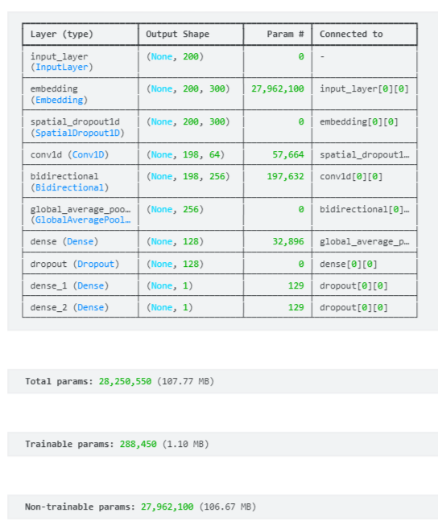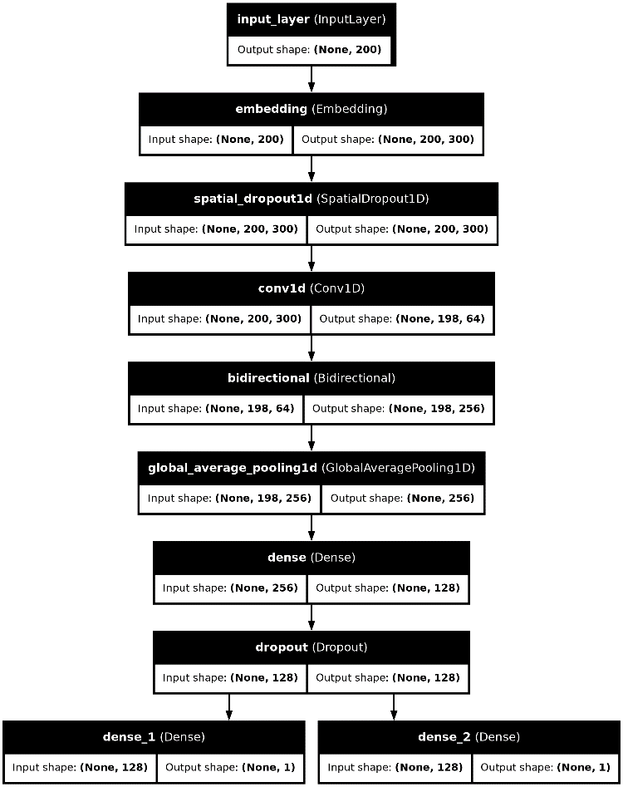

## Training

The model was compiled with the RMSprop optimizer and binary cross-entropy loss

function, suitable for binary classiﬁcation tasks. Training involved several epochs where the model learned to minimize the loss function, adjusting weights through

backpropagation.

# Results

The model 1 achieved the following performance metrics:

* Training Accuracy: Approximately 97.15%
* Validation Accuracy: Approximately 97.23%
* Test Accuracy: Approximately 97.33%

The model 2 achieved the following performance metrics:

* Training Accuracy: Approximately 93.18%
* Validation Accuracy: Approximately 90.58%
* Test Accuracy: Approximately 90.33%

# References

1. Word Embeddings:
   * Pennington, J., Socher, R., & Manning, C. D. (2014). GloVe: Global Vectors for Word Representation.
2. Model Architecture:
   * Hochreiter, S., & Schmidhuber, J. (1997). Long Short-Term Memory.
   * Kim, Y. (2014). Convolutional Neural Networks for Sentence Classiﬁcation.
3. Datasets:
   * “WELFake Dataset,” Kaggle.
   * “Fake and Real News Dataset,” Kaggle.

# Conclusion

The developed model demonstrates a high degree of accuracy in classifying news articles as fake or real. However, further improvements can be explored by experimenting with different architectures, tuning hyperparameters, or using a more diverse and extensive dataset. Future work should also consider the integration of this model into real-world applications, where it can provide immediate beneﬁts in detecting and ﬂagging fake news content.